**INFOLABZ IT SERVICES PVT. LTD.**

**Course :** React

**Assignment No :**

**Topics to be covered :** Wegpages in react

Design Webpages ( with html and css only ) react not required.

Design webpage structures only ( in which you have to create boxes and usually h1 tags as shown below image

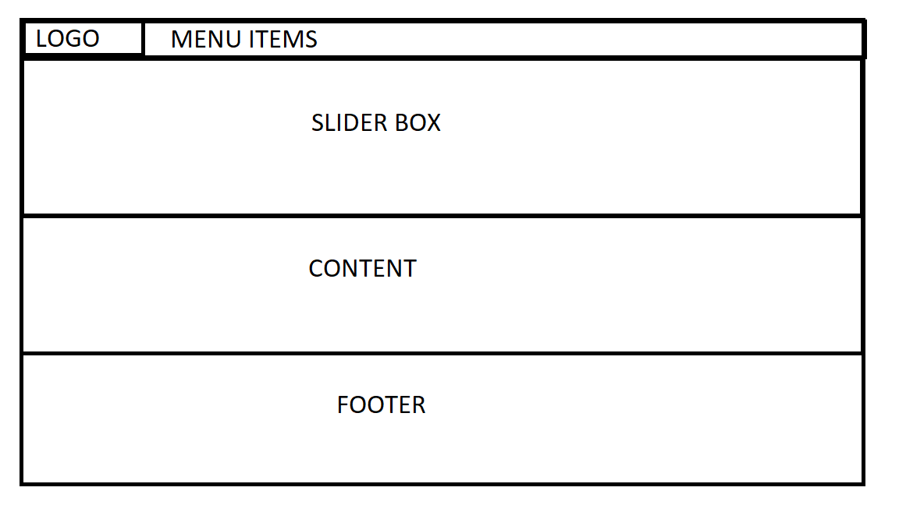

Create following pages

1. Home.html
   1. Menu ( at top )
   2. Slider box
   3. Content box
   4. Footer ( Divide into three parts Address , Links and email id + Logo )

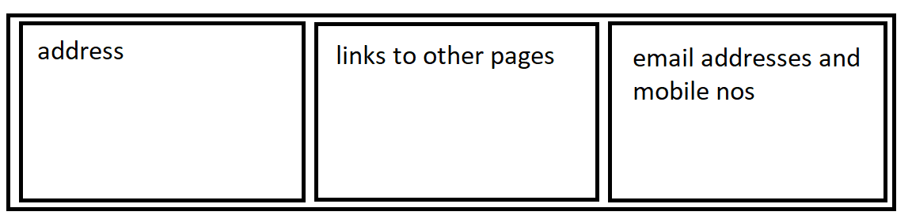

( example of footer )

1. About.html
   1. Menu ( at top )
   2. About industry box
   3. About benefits box
   4. Footer ( Divide into three parts Address , Links and email id + Logo )
2. Services.html
   1. Menu ( at top )
   2. Services box
   3. Footer ( Divide into three parts Address , Links and email id + Logo )
3. Products.htm
   1. Menu ( at top )
   2. Products box
   3. Testimonial box
   4. Footer ( Divide into three parts Address , Links and email id + Logo )

1. Contactus.html
   1. Menu ( at top )
   2. Google map box box
   3. Contact us form box
   4. Footer ( Divide into three parts Address , Links and email id + Logo )

**IMPORTANT : Website project structuring in react**

Create new react project : webstructure

Add 2 folders inside src folder :

1. Common

Add common files like

Menu.js

Footer.js

Slider.js ( same slider can be used in multiple pages )

1. Pages

Home.js

About.js

Services.js

Products.js

Contactus.js

*== Render main page component one by one to Index.js or App component to view entire page designed by you ( do not add hyperlink or routing ) ===*